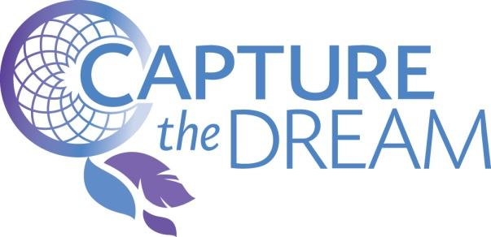

**Dreamcatcher Program**

Client Eligibility & Program Application

|  |  |  |  |  |  |  |  |  |
| --- | --- | --- | --- | --- | --- | --- | --- | --- |
| **Applicant Information** | | | | |  | | | |
| Are you completing this form as the client? | | | | | Yes No | | |  |
| If you checked No, state your name and relationship to the applicant in the spaces provided below. | | | | | | | | |
| First Name, Middle Initial, Last Name: | | | | | Relationship: | | | Today’s Date: |
| Phone Number: | | | | | Email Address: | | |  |
| **Client Information** | | | | |  | | | |
| First Name, Middle Initial, Last Name: | | | | |  | | |  |
| Home Address: | | | | |  | | | |
| City: | | | | | State:  CA | | | Zip: |
| Phone Number: | |  | | | Email Address: | | |  |
| Date of Birth: | | Age: | | | Female  Male | | | US Citizen  Permanent Resident |
| # of Household Members: | | Annual Household Income:  $ | | | | | |  |
| If you are affiliated with a nonprofit organization, please list its name here: | | | | | | | | |
| Have you ever been convicted of a felony?  Yes No  If you checked Yes, please explain: | | | | | | | | |
| **Tell Us About Your Dream** | | | | |  | | | |
| Please feel free to use a separate sheet of paper if you need more space for your answers.  Which category best describes your dreams? | | | | | | | | |
| Education | Cultural | | Sports | Arts | | Career | Other: | |
|  | | | | | | | | |
| What are some of your short term dreams? (Example: To win first place in science fair.)  _______________________________________________________________________________________________  _______________________________________________________________________________________________  _______________________________________________________________________________________________ | | | | | | | | |
| What is your long term dream? (Example: To become a pharmacist.)  _______________________________________________________________________________________________  _______________________________________________________________________________________________  _______________________________________________________________________________________________ | | | | | | | | |
| Why is this dream important to you?  _______________________________________________________________________________________________  _______________________________________________________________________________________________  _______________________________________________________________________________________________  _______________________________________________________________________________________________  _______________________________________________________________________________________________ | | | | | | | | |
| What actions have you taken towards achieving this dream? Please list actions in chronological order.  _______________________________________________________________________________________________  _______________________________________________________________________________________________  _______________________________________________________________________________________________  _______________________________________________________________________________________________  _______________________________________________________________________________________________  _______________________________________________________________________________________________ | | | | | | | | |
| What actions are still needed to achieve your dream? Please be as specific as possible.  _______________________________________________________________________________________________  _______________________________________________________________________________________________  _______________________________________________________________________________________________  _______________________________________________________________________________________________  _______________________________________________________________________________________________  _______________________________________________________________________________________________ | | | | | | | | |
| In what ways can your dream help or benefit our community?  _______________________________________________________________________________________________  _______________________________________________________________________________________________  _______________________________________________________________________________________________  _______________________________________________________________________________________________  _______________________________________________________________________________________________  _______________________________________________________________________________________________  _______________________________________________________________________________________________  How can we help you capture your dream? Please provide specific resources requested along with total estimated dollar value. (Example: Science kit and science books, estimated value of $50.)  _______________________________________________________________________________________________  _______________________________________________________________________________________________  _______________________________________________________________________________________________  _______________________________________________________________________________________________  _______________________________________________________________________________________________  _______________________________________________________________________________________________  _______________________________________________________________________________________________  _______________________________________________________________________________________________ | | | | | | | | |
| How did you hear about our Dreamcatcher program?  _______________________________________________________________________________________________  _______________________________________________________________________________________________  **I certify that the information on this application is true and correct. If any information is found to be untrue, I understand I will be disqualified from this program immediately.**  _____________________________________________________________ __________________________________  Client Signature Date  _____________________________________________________________ __________________________________  Parent/Guardian Signature (Required for Clients Under 18 Years of Age) Date  **Dreamcatcher Application Instructions**   1. Complete, sign, and print the application, not including this Application Instructions page:  * Dreamcatcher Application (Pages 1-3)  1. If you are NOT associated with a nonprofit organization that has already confirmed your low-income status and citizenship/residency, please include the following:  * Most Recent Tax Return **OR** Capture the Dream Low-Income Addendum * Proof of U.S. Citizenship/Residency  1. Please mail completed application and forms to:   Capture the Dream, Inc.  Dreamcatcher Program  484 Lake Park Ave #15  Oakland, CA 94610  After being accepted and matched with a mentor, we will have you complete and submit the following additional forms:   * Signed Waiver of Liability Form * Signed Media Release Form   Any questions regarding this application may be addressed to:  Lisa Wei  Dreamcatcher Program Manager  lisa@capturethedream.org | | | | | | | | |
|  | | | | | | | | |